# SIMPLE DDA

# Positive Line Slope

# 

# 

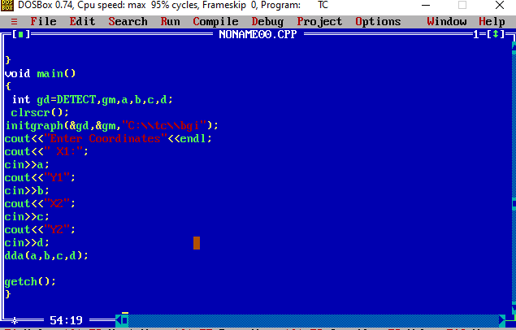

**Output**

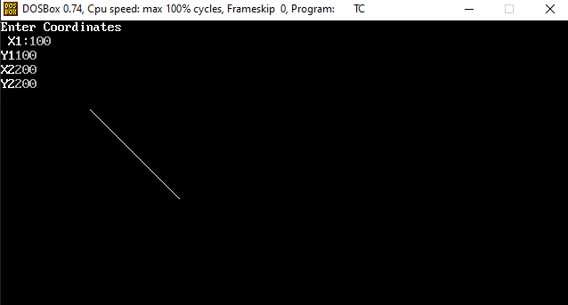

# Negative Line Slope

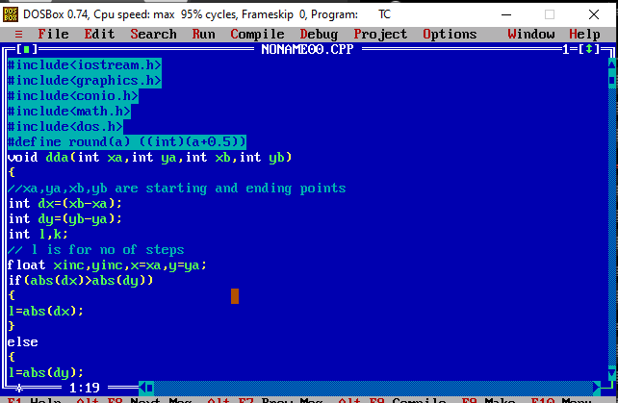

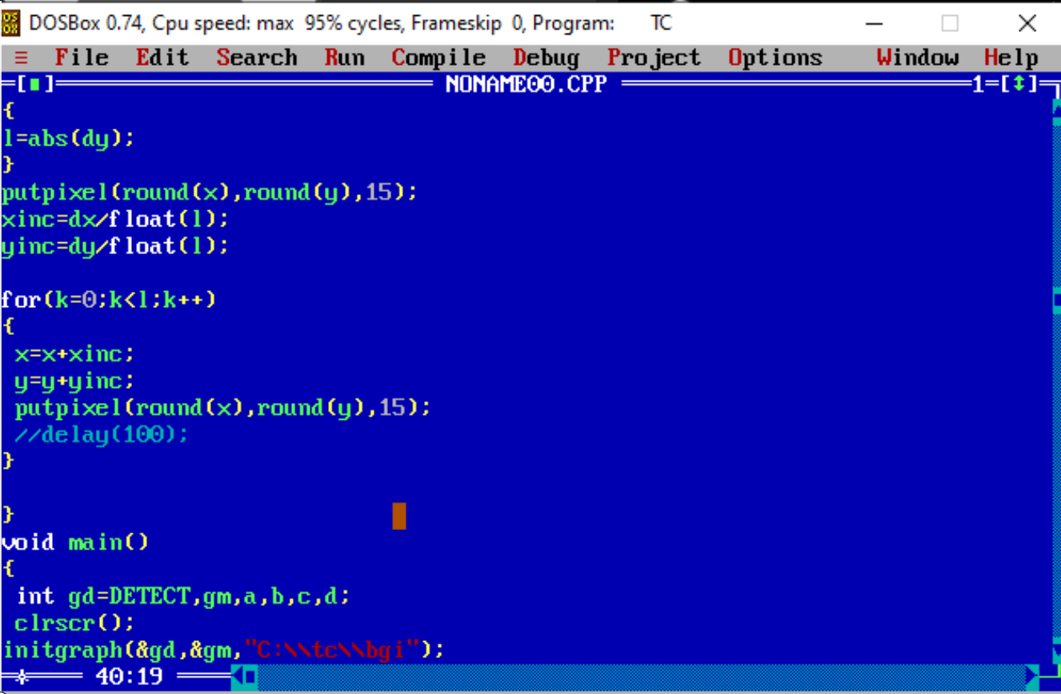



**Output**

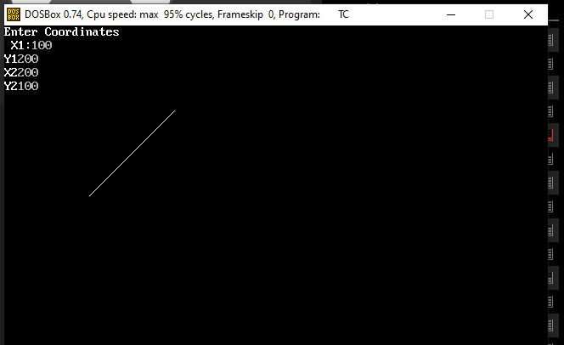

# SYMMTERICAL DDA

# Positive Line Slope

# 

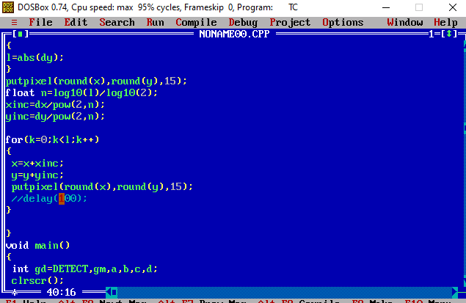



**Output**



# Negative Line Slope







**Output**

